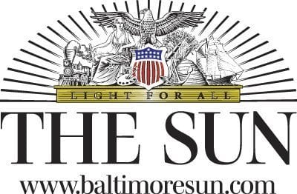

New health secretary’s promises don’t add up | READER COMMENTARY
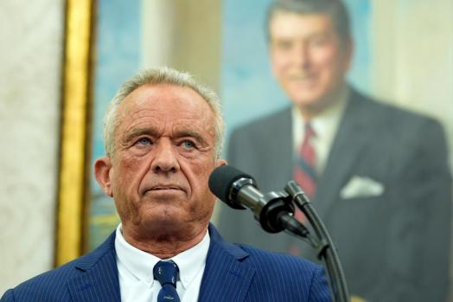
Robert F. Kennedy Jr., speaks after being sworn in as Health and Human Services Secretary in the Oval Office at the White House, Thursday, Feb. 13, 2025, in Washington. (Photo/Alex Brandon)

By READER COMMENTARY
PUBLISHED: February 21, 2025 at 3:45 PM EST
We both attended the U.S. Senate Committee on Health, Education, Labor and Pensions hearing for Robert F. Kennedy Jr. on Jan. 30. When reflecting on the many commitments Kennedy made to U.S. Sen. Bill Cassidy, a Louisiana Republican, that day in order to gain his critical vote to become the next Health and Human Services (HHS) secretary, the words of Dionne Warwick’s song sadly ring true. “You made me promises, promises. Knowing I’d believe promises, promises. You knew I’d never keep.”
Senator Cassidy, a gastroenterologist with over 30 years of experience, proudly claims that he has dedicated his life to saving lives and we do not disagree. Throughout Kennedy’s confirmation hearings, Cassidy reiterated his support for vaccines, having personally witnessed their rigorous safety monitoring and effectiveness throughout his career. He also brought up his grave reservations about Kennedy’s past conspiracy theories and vaccine cynicism.
In order to vote yes to confirm Kennedy, Cassidy obtained several promises. He made it clear during his floor speech that preceded the full Senate vote he would be watching for any efforts made by Kennedy that would wrongfully sow public doubt about vaccines. Yet, just days after being sworn in and despite his pledge that he would not change the nation’s current vaccination schedule, in his very first address to HHS employees, Kennedy vowed to investigate the childhood vaccine schedule that prevents measles, polio and other dangerous diseases (“Kennedy says panel will examine childhood vaccine schedule after promising not to change it,” Feb. 18).
The fledgling HHS secretary’s timing could not be worse. Currently, there is a serious outbreak of measles in Texas with 58 reported cases, most of these in children. Measles is dangerous, potentially deadly, highly contagious and is spreading rapidly to other states.
Kennedy also has a history of drawing false conclusions about vaccines, often linking them to unrelated, unproven end results. His most widely known and repeated lie is that vaccines cause autism. They do not. Now, in his mission to “make America healthy again” by decreasing chronic health conditions, he announced he wants an investigation linking the cause of these diseases to vaccinations. Several meta-analysis studies have tested this hypothesis and found that no link exists between vaccines and chronic disease.
Doctors for America and Nurses for America opposed Kennedy’s nomination, never fooled by RFK Jr’s insincerity. This may have been his first promises broken, but they will not be the last. Senator Cassidy, it’s your move now
02:40
Read More
— Timothy Holtz, M.D. and Teri Mills, R.N., Chevy Chase
The writers are, respectively, a professor at the George Washington University Milken Institute School of Public Health and the former president of the National Nursing Network Organization.

